1. Create a Node.JS Application which serves a static website.

**Makesure you have installed NodeJS , ExpressJS and VSCode**

1. Create Folder named Ass_3_A and run cmd for that path
2. You will enter cmd and type

**npm init –y**

command to create a new **package.json** file, which will **store metadata about your project** and its dependencies:

**npm install express**

This command will install the latest version of Express.js

**//if not installed already**

**npm list express**

see it listed along with its version number.

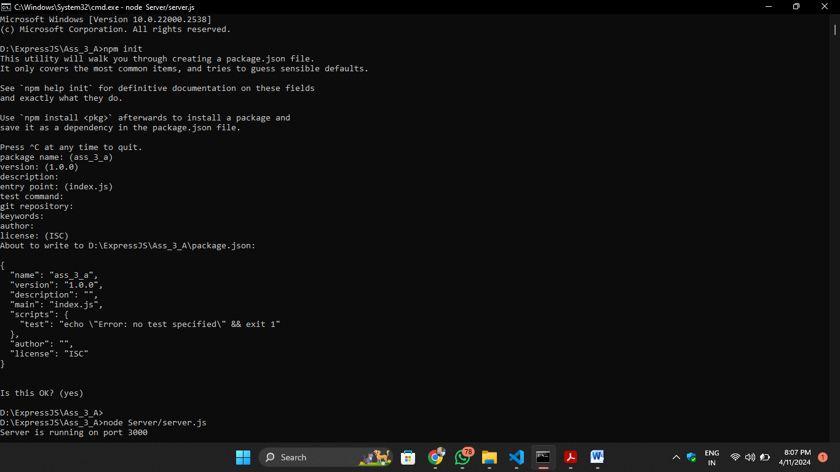

1. In VSCode open the folder **Ass_3_C and in that folder create 2 separate folders**
2. **Server Folder –**

**Set up your Node.js server:**

**Inside the server folder, create a file named server.js.**

**Write below code:**

// server/server.js

const express = require('express');

const path = require('path');

const app = express();

// Serve static files from the 'public' directory

app.use(express.static(path.join(__dirname, '../public')));

// Start the server

const PORT = process.env.PORT || 3000;

app.listen(PORT, () => {

    console.log(`Server is running on port ${PORT}`);

});

1. **Public Folder**

Create your **static website files**:

Inside the public folder, create an **HTML file (e.g., index.html**) and any other assets (like CSS, JavaScript, images) that your website requires

Write below code:

<!-- public/index.html -->

<!DOCTYPE html>

<html lang="en">

<head>

    <meta charset="UTF-8">

    <meta name="viewport" content="width=device-width, initial-scale=1.0">

    <title>My Static Website</title>

    <link rel="stylesheet" href="styles.css">

</head>

<body>

    <h1>Welcome to My Static Website</h1>

    <p>This is a simple static website served by a Node.js application.</p>

    <script src="script.js"></script>

</body>

</html>

/* public/styles.css */

body {

    font-family: Arial, sans-serif;

    background-color: #f0f0f0;

}

h1 {

    color: #333;

}

p {

    color: #666;

}

// public/script.js

// Example JavaScript code

console.log('Script loaded!');

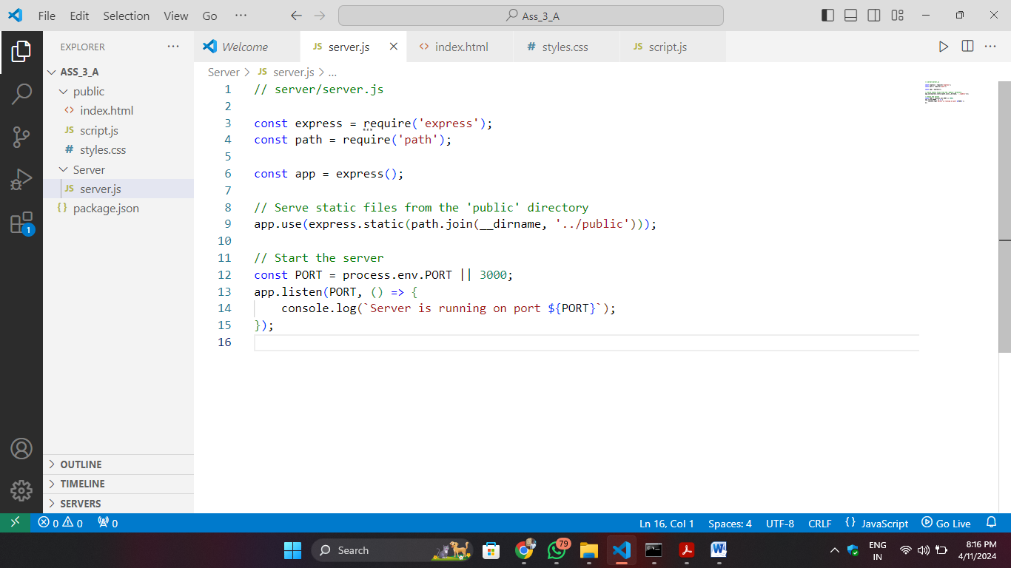

1. **Start your server:**

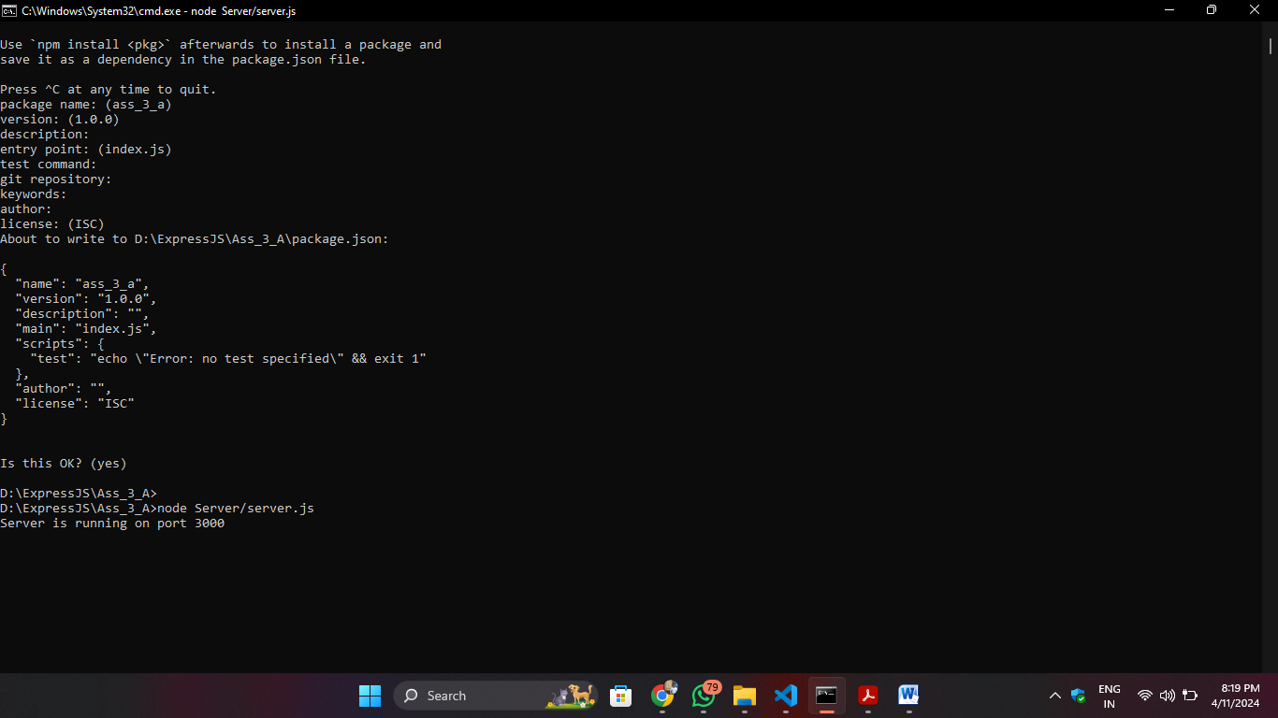 Run ***node Server/server.js*** from your project root directory on cmd.